Multi-Model Haptic Assistive Glove with Guardian Monitoring for the Visually Impaired
Muhammad Hazimuddin bin Fairuz
Department of Mechatronics
Kulliyyah of Engineering,
International Islamic University, Gombak, Selangor
hazimuddinfairuz@gmail.com
Muhammad Fahim Bin Ahmad Norisham
Department of Mechatronics
Kulliyyah of Engineering,
International Islamic University, Gombak, Selangor
itsfahimyall@gmail.com
Muhammad Zamarul Azim Bin Zulkhibri
Department of Mechatronics
Kulliyyah of Engineering,
International Islamic University, Gombak, Selangor
zamarulazim0509@gmail.com
Abstract—Visually impaired individuals face persistent challenges in locating personal belongings within indoor environments. Existing commercial trackers predominantly rely on visual smartphone interfaces, limiting their usability for blind users. This paper presents a multi-modal assistive glove for indoor object localization that integrates tactile feedback, audio cues, and remote guardian monitoring. The proposed system employs an ESP32-based wearable glove equipped with a HuskyLens vision sensor for AprilTag detection, a secondary ESP32 attached to the target object for audio signalling, and a Raspberry Pi monitoring hub that provides real-time guardian notifications via Telegram. Low-latency peer-to-peer communication between the wearable glove and the object unit is achieved using ESP-NOW, enabling direct MAC-address-based control without pairing or network association. A finite state machine governs system operation to ensure reliable feedback and minimize false activations. Experimental evaluation demonstrates a detection accuracy of 90% within a 0.8 m range and local feedback latency below 500 ms. The results indicate that the proposed system offers an effective and low-cost solution for assisting visually impaired users in locating personal items indoors while enabling external safety monitoring.
Keywords—Assistive Technology, Visually Impaired, ESP32, ESP-NOW, HuskyLens, AprilTag, Tactile Feedback, Guardian Monitoring, Indoor Localization

Introduction
A. Problem Statements
Visually impaired individuals encounter persistent difficulties in locating personal belongings such as keys, wallets, or mobile devices within indoor environments. Unlike outdoor navigation, where GPS-based assistance may be effective, indoor object localization relies heavily on visual search strategies that are inaccessible to blind users. Although various object tracking technologies exist, many assume the availability of visual feedback or smartphone-based interfaces, limiting their practicality for visually impaired users. Consequently, there remains a lack of accessible indoor localization solutions that provide intuitive, non-visual guidance for real-time object searching.
B. Motivation
Independent access to personal belongings is essential for maintaining autonomy and safety among visually impaired individuals. Existing assistive technologies primarily focus on navigation and obstacle avoidance, while comparatively little attention has been given to the task of locating everyday objects within confined indoor spaces. Furthermore, reliance on audio feedback alone may be insufficient in noisy environments and can increase cognitive load. These challenges motivate the development of an assistive system that emphasizes tactile interaction, minimizes dependency on visual interfaces, and supports safer object search behaviour through optional guardian monitoring.
C. Limitations of Existing Solutions
Commercial tracking devices such as Apple AirTag [5] and Tile trackers [6] are commonly used for locating lost items. While these devices provide accurate location information, they rely heavily on smartphone-based visual interfaces. Directional guidance is typically displayed on a screen, making it unsuitable for blind users. Audio feedback alone is often insufficient for precise indoor localization.
Research-based assistive systems often focus on navigation or obstacle detection rather than personal item localization. Some systems require complex computation, expensive hardware, or continuous internet access, which limits their practicality for daily use. Furthermore, research-based assistive systems often focus on navigation or obstacle detection rather than personal item localization. For instance, ultrasonic-based smart sticks [7], [8] and IoT-enabled canes [9] excel at detecting walls and ground obstacles but lack the semantic ability to identify specific personal items like a wallet or keys. Most existing solutions also do not include guardian monitoring.
D. Contributions of the Proposed System
This paper proposes a wearable, multi-modal indoor object localization system designed specifically for visually impaired users. The main contributions of this work are as follows:
- Development of a wearable assistive glove providing tactile guidance.
- Integration of AprilTag-based object recognition using HuskyLens.
- Separation of user intent and guidance logic via button-initiated search.
- Implementation of low-latency ESP-NOW–based MAC-address peer-to-peer communication between distributed ESP32 units.
- Implementation of guardian monitoring with Telegram notifications.
- Design of a low-cost indoor localization system.
E. Comparison with Existing Solutions
TABLE I Comparison of Existing Indoor Object Localization Solutions
Ref / Year | Title / Product | Advantages | Disadvantages | Comparison to Proposed System
Apple (2021) | AirTag | Accurate tracking, compact | Visual-based, limited tactile | Adds vibration-based guidance
Tile (2020) | Tile Tracker | Audio alert, affordable | No direction feedback | Integrates vision detection
Pratap (2025) | Indoor Assistive System | Vision-based recognition | Non-wearable, high cost | Wearable and low-cost design
Proposed | Assistive Glove | Tactile & Guardian monitoring | Indoor focus | Specific for the visually impaired

Methodology

Overall System Architecture
The proposed Assistive Glove with Guardian Monitoring system is designed as a modular indoor object localization platform consisting of three main subsystems, which are the Assistive Glove Unit, the Object Receiver Unit, and the Guardian Monitoring Unit. A diagram illustrating the interaction between the subsystems is shown in Fig. 1.
The Assistive Glove Unit functions as the primary user interface and guidance system for the visually impaired user. The Object Receiver Unit is attached to the target object and provides audio feedback. The Guardian Monitoring Unit, implemented using a Raspberry Pi 5, supervises system activity and provides visual and remote notifications. Communication between subsystems is achieved using ESP-NOW, Bluetooth, and Wi-Fi connections, selected according to latency and functional requirements to ensure reliable short-range indoor operation.
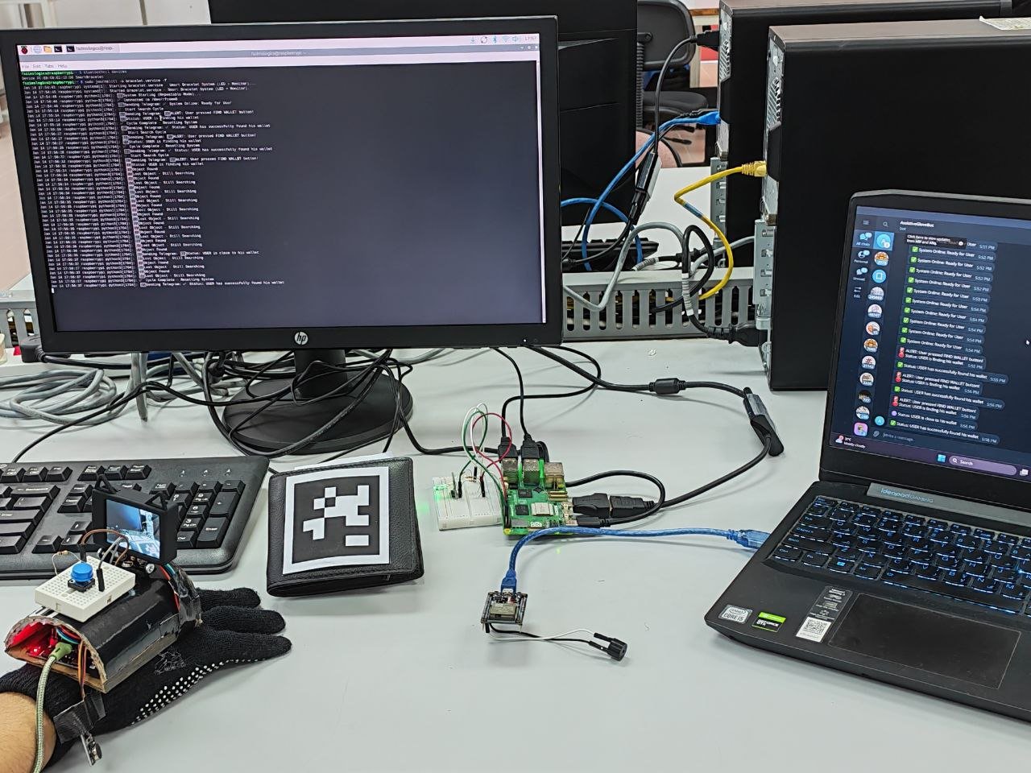
Figure 1

Assistive Glove Unit
The Assistive Glove Unit is built around an ESP32 microcontroller and serves as the wearable interface for the user. As illustrated in Fig. 2, the glove integrates a push button, a vibration motor module, and a HuskyLens vision sensor.
The push button is used to initiate and terminate the object search process. When pressed, a wireless signal is transmitted to both the Object Receiver Unit and the Guardian Monitoring Unit. The vibration motor provides tactile feedback to the user and is activated only when the HuskyLens detects the AprilTag attached to the target object. This design ensures that tactile feedback is proximity-based rather than user-triggered, reducing cognitive load for visually impaired users.
The HuskyLens camera continuously scans the environment during the search phase. Upon successful detection of the AprilTag, the ESP32 activates the vibration motor as a signal to guide the user toward the object.
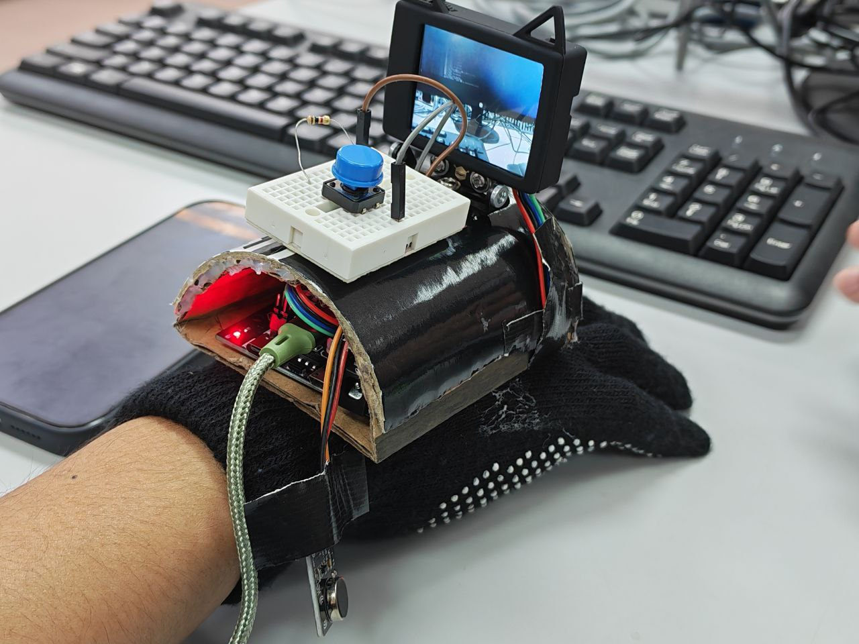
Figure 2

Object Receiver Unit5
The Object Receiver Unit is attached directly to the target object, such as a wallet. This subsystem consists of an ESP32 microcontroller and a buzzer, as shown in Fig. 3. When a search request is received from the Assistive Glove Unit, the ESP32 activates the buzzer to generate an audible cue sound, allowing the user to estimate the object’s general location and distance within the indoor environment. The buzzer remains active until the user terminates the search by pressing again the button on the glove.
The AprilTag marker is physically attached to the object, just as shown in Fig.4 and is used exclusively by the HuskyLens for visual detection and proximity guidance.
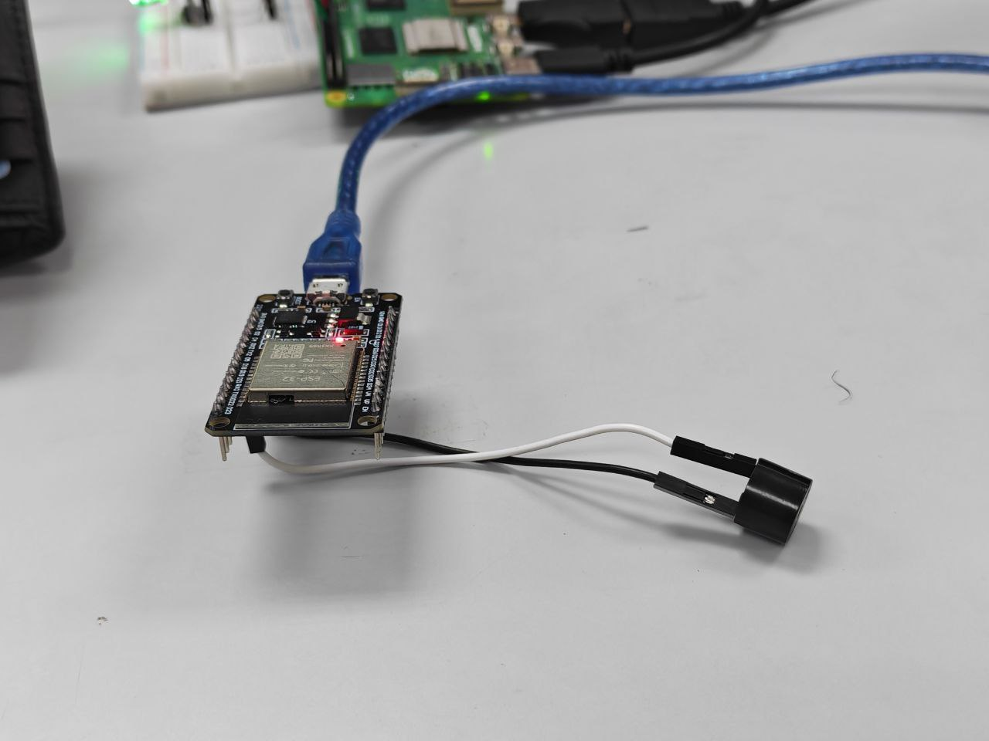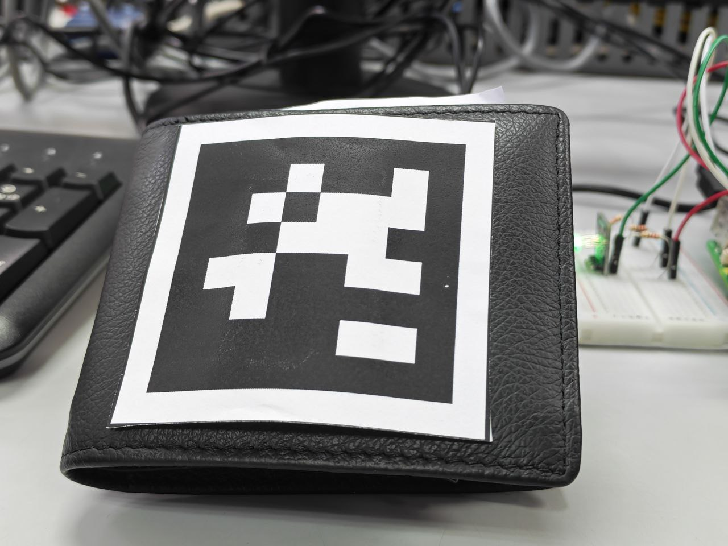
Figure 3 Figure 4
  - Guardian Monitoring Unit
The Guardian Monitoring Unit is implemented using a Raspberry Pi 5 [15] and functions as a stationary home hub. This unit receives wireless signals from the Assistive Glove Unit and updates system status accordingly. An RGB LED connected to the Raspberry Pi, as shown in Fig. 5, provides a visual indication of the system state, as summarized below.
- Green indicates idle state
- Red indicates active object search
- Purple indicates it aproximity close to the target object
In addition, the Raspberry Pi sends real-time notifications to a guardian via a Telegram Bot API[14] using an internet connection. Notifications include search initiation, proximity detection, and successful object retrieval just as shown in Fig.6. This feature allows caregivers or family members to remotely monitor the user’s activity and provide assistance if necessary.
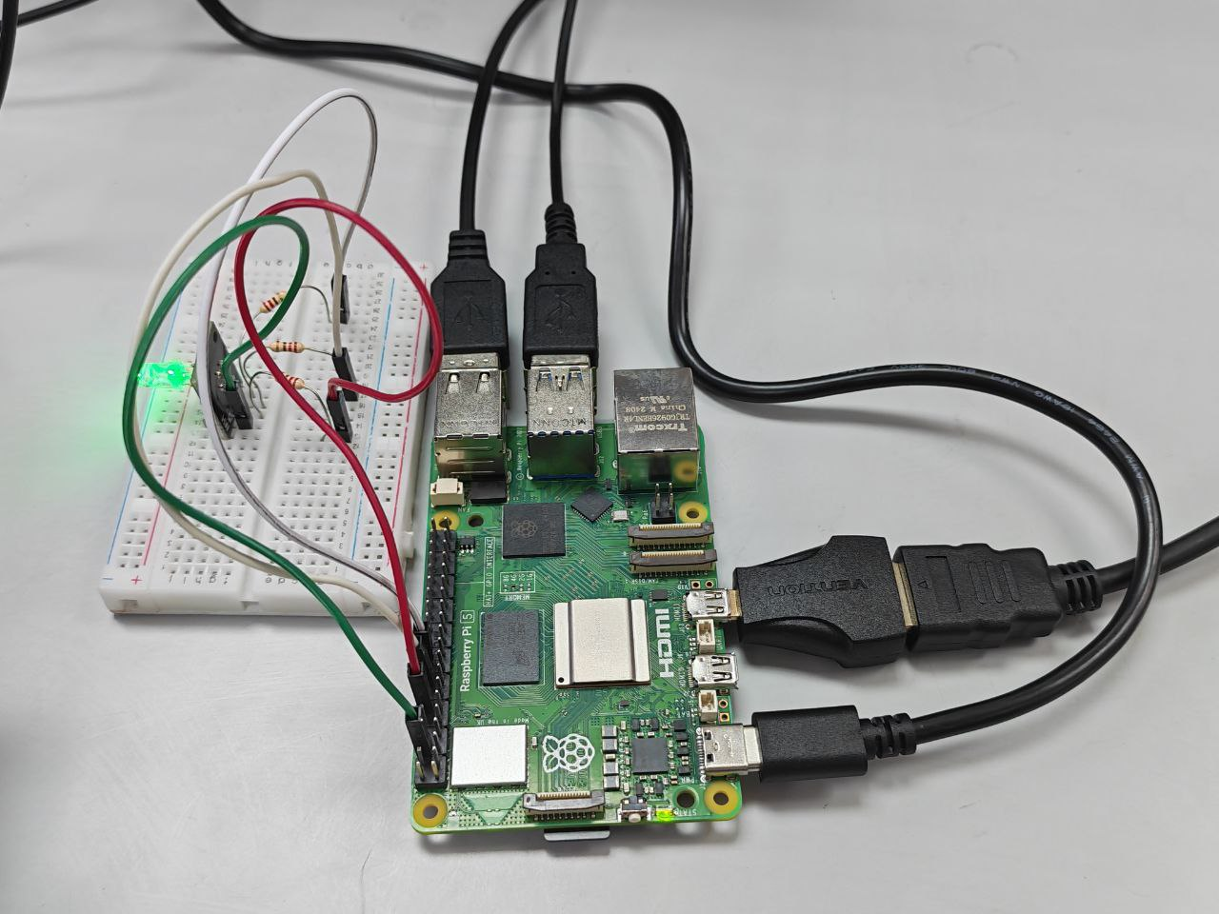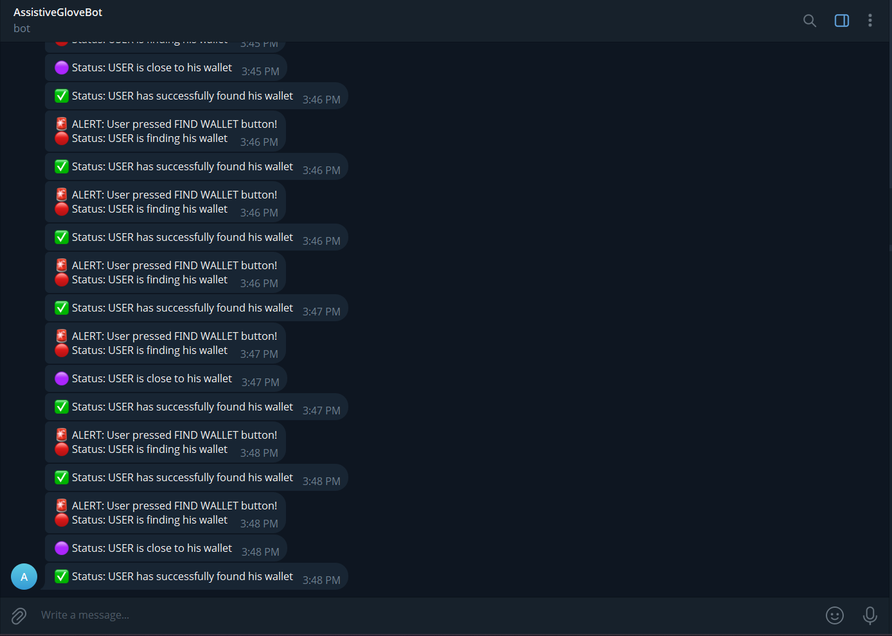
Figure 5 Figure 6
  - System Workflow and Operational Logic
The operational logic of the Assistive Glove is governed by a Finite State Machine (FSM) architecture, ensuring that the system transitions predictably between its four distinct modes: Idle, Searching, Found, and Success. Upon powering up, the Raspberry Pi 5 initializes the Bluetooth Serial connection with the ESP32 Assistive Glove Unit and authenticates the Telegram Bot API. The system defaults to an Idle State, indicated by a Green LED on the monitoring hub. In this state, the system conserves processing power by ignoring camera data and waiting for a specific user input to begin the cycle.
The active cycle is initiated when the visually impaired user presses the push-button on the glove, transitioning the system into the Searching State. This action triggers a cascade of immediate feedback: the LED indicator shifts to Red, and a "User Finding Wallet" alert is broadcast to the guardian's Telegram apps. This separates the user's intent from the actual detection, ensuring that guardians are aware that the user is actively searching even if the object has not yet been found.
While in the Searching State, the system continuously polls the HuskyLens vision sensor. If the camera detects the specific AprilTag attached to the target object, the system transitions to the Found State. This triggers the glove's vibration motor to provide instantaneous haptic guidance to the user. Simultaneously, the monitoring hub updates its status LED to Purple and sends a "User Close" notification to the guardian, confirming that the object is within the user's immediate reach.
The cycle concludes when the user retrieves the object and releases the push-button, triggering the Success State. The system detects the signal drop, immediately deactivating the vibration motor and resetting the LED indicator to Green. A final "Successfully Found" message is sent to the guardian to close the monitoring loop, and the software variables are reset, returning the system to the Idle State in preparation for the next attempt.
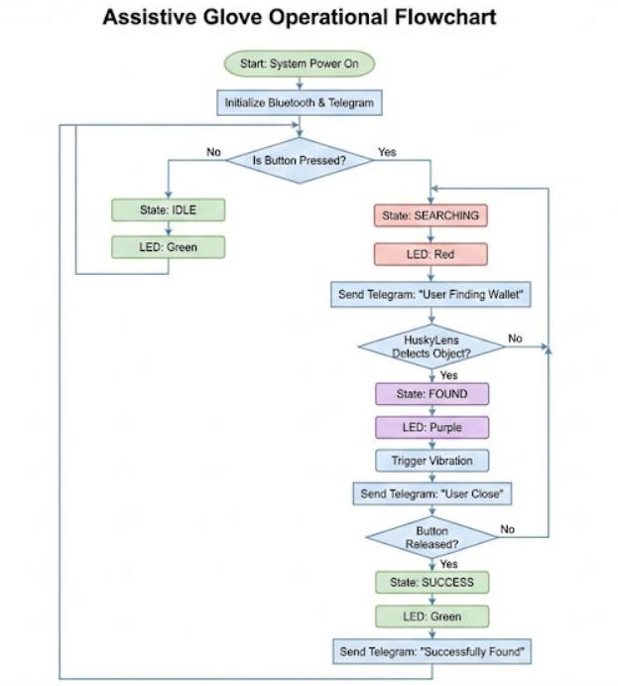
Figure 7

Hardware Design and Prototype Setup
The hardware implementation of the proposed system is divided into three distinct subsystems: the Assistive Glove Unit, the Object Receiver Unit, and the Guardian Monitoring Unit. The electrical design prioritizes modularity and ease of assembly. The Assistive Glove Unit interfaces an ESP32 microcontroller [12] with a push-button input and a vibration motor output. To facilitate robust connections and simplify wiring, the ESP32 is mounted onto an extension board. This expansion shield provides accessible headers for connecting the HuskyLens vision sensor via I2C/UART and the tactile feedback components. The push-button circuit utilizes a pull-down resistor configuration to ensure reliable signal detection, while the vibration motor is driven by a transistor-based driver circuit protected by a flyback diode.
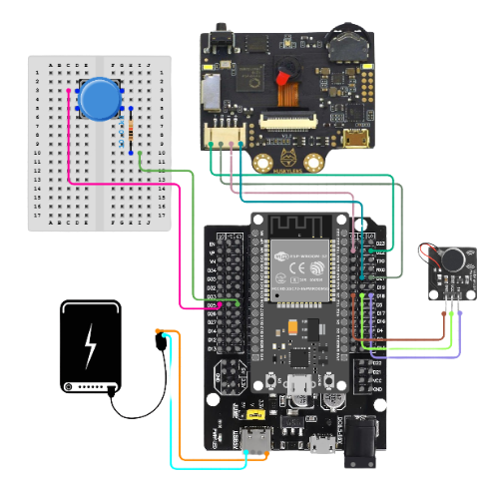
Figure 8
Power management for the wearable glove is streamlined by utilizing a portable USB power bank rather than discrete Lithium cells. The power bank connects directly to the ESP32 extension board, as shown in Fig. 8, which serves as the central power distribution hub. Since the HuskyLens vision sensor [13] requires a regulated 5V supply for AI image processing., the extension board efficiently routes the 5 V from the power bank directly to the sensor's power pins, bypassing the need for additional DC-DC boost converters or complex charging circuits (like the TP4056). This setup ensures that both the high-power vision sensor and the 3.3 V logic of the ESP32 receive stable voltage levels during active searching.
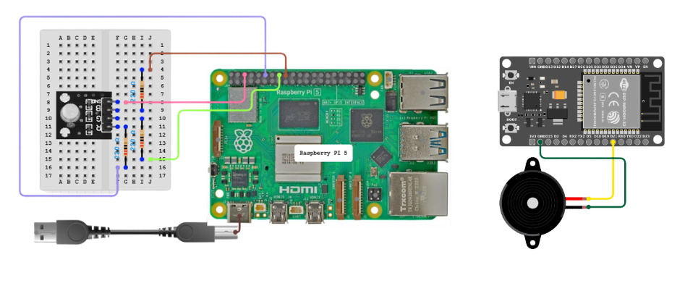

Figure 9
The Object Receiver Unit and Guardian Monitoring Unit utilize independent power configurations tailored to their stationary or semi-stationary roles. The Object Receiver Unit, attached to the target item, is powered by a compact battery setup to maintain a small form factor, connecting a piezoelectric buzzer to a secondary ESP32. The Guardian Monitoring Unit (Raspberry Pi 5) operates as the high-performance central hub. It is powered via a standard 5V USB-C power adapter or a high-capacity power source, ensuring continuous uptime to process Bluetooth signals and maintain the Telegram bot connection without interruption.
- Software Design

ESP32 Firmware Logic
The ESP32 microcontrollers are programmed to operate using event-driven firmware logic. Each ESP32 performs specific tasks based on its role in the system. The ESP32 embedded in the assistive glove continuously monitors the state of the push button and the output of the HuskyLens vision sensor.
When the user presses the button, the firmware sends a wireless command to the Object Receiver Unit and the Guardian Monitoring Unit to initiate or terminate the object search process. During an active search, the ESP32 continuously receives detection data from the HuskyLens. The vibration motor is activated only when the HuskyLens successfully detects the AprilTag attached to the target object. This ensures that tactile feedback is provided based on proximity rather than manual input.
The ESP32 attached to the target object runs a simplified firmware that listens for incoming search commands. Upon receiving a valid command, the firmware activates the buzzer to provide an audible cue. The buzzer remains active until a stop command is received from the Assistive Glove Unit.

Raspberry Pi Logic
The Raspberry Pi 5 operates as the central monitoring and notification unit of the system. A Python-based script is executed to handle incoming wireless messages, control the RGB indicator, and manage Telegram notifications.
When a search request is received from the Assistive Glove Unit, the Raspberry Pi updates the RGB LED state from green to red and sends a notification to the guardian through a Telegram Bot. If a proximity detection message is received, indicating that the AprilTag has been detected, the RGB LED changes from red to purple and a proximity alert is sent.
Once the search is terminated, the Raspberry Pi resets the system state by turning the RGB LED back to green and sending a completion message. The Raspberry Pi does not perform complex image processing, which allows it to operate reliably as a lightweight monitoring hub.
  - Communication Protocol

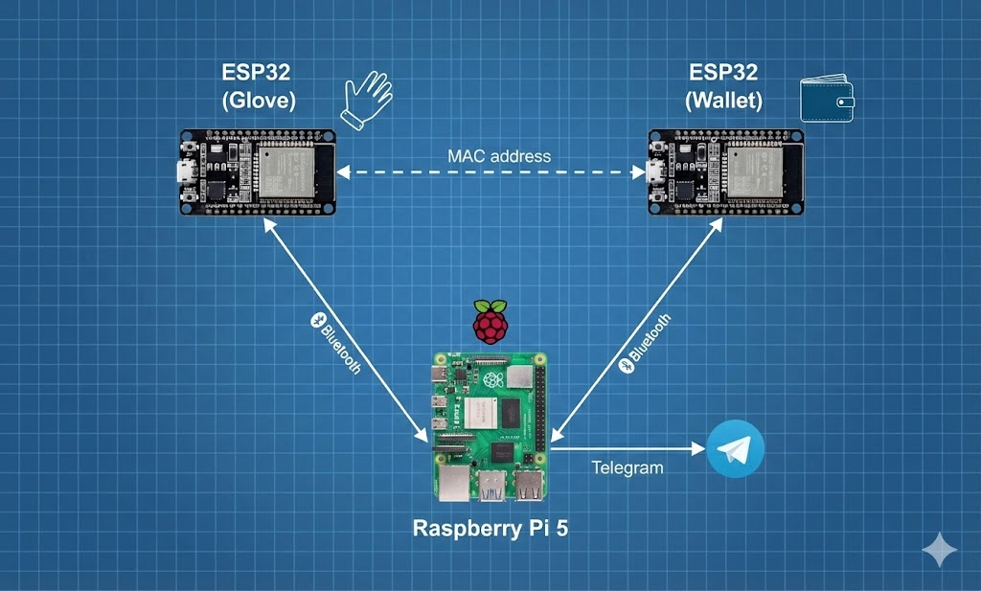
Figure 10
Wireless communication within the proposed system is implemented using multiple communication links, each selected according to the functional role of the subsystem.
Communication between the Assistive Glove Unit and the Object Receiver Unit is implemented using ESP-NOW, a low-latency, connectionless peer-to-peer protocol supported by ESP32 microcontrollers. Each device is identified by a unique MAC address, allowing direct addressing without pairing or network association. ESP-NOW is used to transmit lightweight control commands such as search initiation and termination, ensuring deterministic message delivery and minimal latency. This protocol was selected over Bluetooth-based communication to avoid connection overhead and pairing delays during short, time-critical transmissions.
The Assistive Glove Unit also maintains a Bluetooth serial connection with the Raspberry Pi 5, which serves as the Guardian Monitoring Unit. Through this serial Bluetooth link, the glove transmits system state updates, including search initiation, object detection events, and search termination. The use of Bluetooth serial communication provides low‑latency, short‑range data transfer suitable for indoor environments while avoiding reliance on continuous internet connectivity for core system operation.
The Raspberry Pi 5 connects to the internet via Wi‑Fi and functions as a gateway between the local Bluetooth network and the remote guardian interface. System status updates received from the glove unit are relayed to the guardian using the Telegram Bot API. This communication channel is event‑based, transmitting messages only when a system state change occurs, thereby reducing unnecessary network traffic while enabling real‑time remote monitoring.
- Results and Discussions

Detection Range
The detection range of the system was evaluated through indoor testing. Based on Figure 11 below, the HuskyLens was able to reliably detect the AprilTag using Tag Recognition mode at distances up to approximately 0.6–0.8 m under normal lighting conditions. Beyond this range, detection became inconsistent, and vibration feedback was not activated.
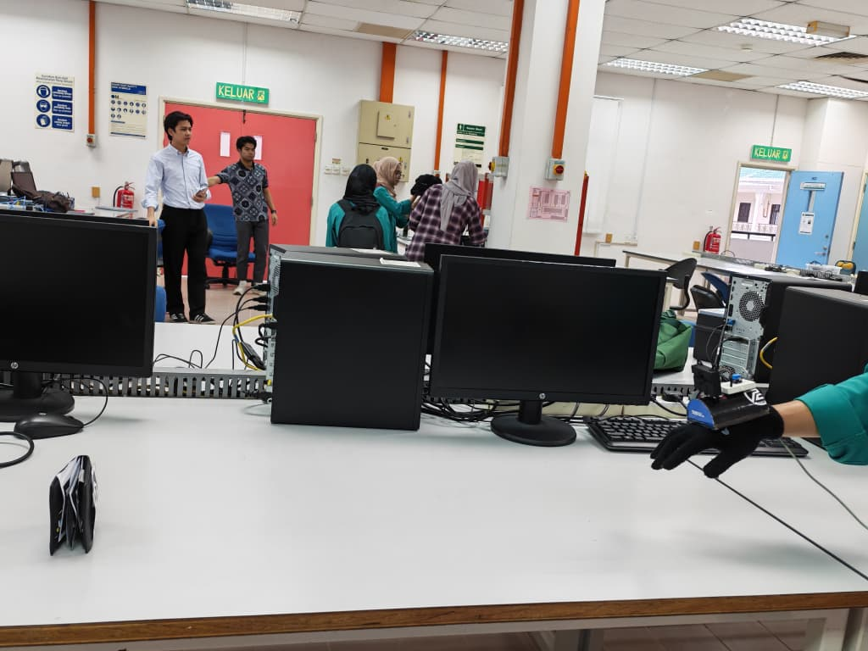
Figure 11
Wireless communication between the Assistive Glove Unit ESP32 and the receiver object ESP32 via ESP-NOW Mac Address was successfully maintained up to 15–20 m indoors without obstruction. The communication between the glove equipped with the ESP32 microcontroller and the Raspberry Pi demonstrated inadequate performance due to the limitations associated with Bluetooth and WiFi connectivity. This reliance on wireless protocols resulted in challenges, including increased latency and inconsistent data transmission, which ultimately impacted the overall effectiveness of the system.
These distances are sufficient for typical indoor use and meet the functional requirements of the proposed system.
TABLE II Detection Range of System Components
Subsystem | Measured Range | Test Environment
HuskyLens → AprilTag | 0.6 – 0.8 m | Indoor, normal lighting
ESP32 (Glove) →  ESP32 (Object) | 15 – 20 m | Indoor, no obstruction
ESP32 (Glove) → Raspberry Pi | 5 – 10 m | Indoor, WiFi/Bluetooth

Response Latency
Response latency was measured by recording the time delay between user input and system response. The average delay between button activation and buzzer response was approximately 300–500 ms. Vibration feedback triggered by AprilTag detection showed a similar response time.
Telegram notifications experienced a longer delay of approximately 2-4 s, depending on internet connectivity. Despite this, the latency remained acceptable for monitoring and assistance purposes.

TABLE III Average Response Latency
Action | Average Delay
Button press → Buzzer | 0.3 – 0.5 s
AprilTag detection → Vibration | -
Event → Telegram notification | 2 – 4 s
The results show that local feedback mechanisms respond rapidly, while cloud-based notifications introduce higher latency due to network dependency.
  - Accuracy
The accuracy of the vision-based detection was evaluated through repeated testing. Out of 20 trials, the HuskyLens correctly detected the AprilTag and activated vibration feedback in 18 cases, resulting in an accuracy of approximately 90%. False detections mainly occurred under poor lighting conditions or when the AprilTag was partially occluded.
  - Power Consumption
The wearable unit is powered by a portable USB powerbank. During testing, the system was able to operate continuously for approximately 4–6 hours under normal usage conditions. Power consumption was reduced by limiting vibration feedback to only when AprilTag detection occurred.
These results indicate that the system is suitable for daily indoor use without frequent recharging.
TABLE IV Estimated Power Performance
Component | Power Behavior
ESP32 | Moderate consumption
Vibration motor | Short-duration bursts
HuskyLens | Active only during scanning
  - User Interaction Analysis
The system was designed with minimal user interaction to suit visually impaired users. The operation requires only a single button press to initiate or terminate a search. Tactile feedback through vibration eliminates the need for visual confirmation, while audible cues assist in object localization.
The inclusion of guardian monitoring through Telegram enhances safety by allowing external assistance if the user experiences difficulty or prolonged search time. Overall, the system demonstrates high usability and accessibility for blind users.
- System Integration and discussion
The proposed assistive system integrates three main subsystems: the assistive glove unit, the object locator unit, and the guardian monitoring unit. System integration was evaluated by analyzing how these subsystems communicate, synchronize feedback, and respond to user actions in real-time.
When the user presses the search button on the assistive glove, the ESP32 immediately sends a wireless command to be received by the object ESP32 using its MAC address via ESP-NOW. This triggers the buzzer attached to the target object, providing an audible cue to help the user identify the general direction of the item. At the same time, the Raspberry Pi receives the search event via Bluetooth serial and changes the RGB indicator from green to red, indicating that the system is in active search mode. A notification is also sent to the guardian through the Telegram bot, informing them that the user is attempting to locate a personal item.
As the user moves closer to the object, the HuskyLens mounted on the glove continuously scans the environment for the AprilTag attached to the object. Once the AprilTag is detected, the vibration motor on the glove is activated to provide tactile feedback. This vibration-based guidance allows the user to fine-tune their movement without relying on sound only, which is particularly useful in noisy indoor environments. During this phase, the Raspberry Pi 5 updates the RGB indicator to purple, signalling proximity to the object, and sends an updated status message to the guardian.
After the object is successfully located, the user presses the button again to stop the search process. This action deactivates the buzzer, resets the RGB indicator to green, and updates the system state to idle mode. The guardian is also notified that the search process has ended. Throughout the operation, local feedback mechanisms such as the buzzer and vibration motor respond faster than cloud-based notifications, ensuring that the user receives immediate guidance even if internet connectivity is unstable.

Overall, the integration results demonstrate that the three subsystems operate cooperatively with minimal delay and no functional conflict. The combination of auditory, tactile, visual, and network-based feedback creates a robust and user-friendly assistive system. This integrated approach improves reliability, enhances safety, and allows guardians to remotely monitor and assist visually impaired users when necessary.
- Conclusion

The development of the Multi-Modal Assistive Glove with Guardian Monitoring successfully addresses the limitations of existing object tracking solutions by integrating active computer vision with remote safety monitoring. Unlike passive Bluetooth trackers, this system provides visually impaired users with semantic understanding of their environment through the HuskyLens, confirming not just the location but the identity of the target object. The implementation of the "Strict Cycle" Finite State Machine ensures that tactile feedback is reliable and false alarms are minimized, while the integration of the Telegram Bot API creates a crucial safety net, allowing guardians to monitor the user's independence from anywhere. Experimental results confirm that the system operates with low latency (<500ms for local feedback) and high detection accuracy (90% within 0.8m). Future iterations of the project will focus on optimizing the form factor to further reduce weight and integrating GPS modules to expand the system’s functionality to outdoor environments.

- Acknowledgement

The authors would like to thank the Department of Mechatronics Engineering at the International Islamic University Malaysia (IIUM) for providing the laboratory facilities and technical resources necessary for this research. Special appreciation is extended to the laboratory staff for their guidance on component integration and prototyping.
- Author Contributions

All authors contributed equally to the conceptualization and design of the study. M. H. Fairuz led the hardware development, including the circuit design and glove prototyping. M. F. A. Norisham developed the firmware logic for the ESP32 and the Python scripts for the Raspberry Pi Guardian Unit. M. Z. A. Zulkhibri conducted the experimental validation, data collection, and performance analysis. All authors participated in the writing, review, and final approval of the manuscript.

- References

[1] A. V. Nandini, A. Dwivedi, N. A. Kumar, T. S. Ashwin, V. Vishnuvardhan, and R. M. R. Guddeti, "Smart Cane for Assisting Visually Impaired People," in 2019 IEEE Region 10 Conference (TENCON), Kochi, India, 2019, pp. 546-551.

[2] World Health Organization, "World report on disability," 14 Dec. 2020. [Online]. Available: https://www.who.int/publications/i/item/9789241564182.

[3] Y.-H. Liu, H.-Y. Su, H.-C. Lin, C.-Y. Li, Y.-H. Wang, and C.-H. Huang, "Investigation of Achieving Ultrasonic Haptic Feedback Using Piezoelectric Micromachined Ultrasonic Transducer," Electronics, vol. 11, no. 14, p. 2131, 2022.

[4] S. Ouyang et al., "Risk Factors of Falls in Elderly Patients with Visual Impairment," Frontiers in Public Health, vol. 10, 2022. [Online]. Available: https://doi.org/10.3389/fpubh.2022.984199.

[5] Apple Inc., "AirTag - Keep track of your keys, wallet, luggage, backpack, and more," 2021. [Online]. Available: https://www.apple.com/airtag/.

[6] Tile Inc., "Tile Tracker: Bluetooth Trackers for Keys, Wallets, Phones & More," 2020. [Online]. Available: https://www.thetileapp.com/.

[7] N. Dey, N. Ankita, C. S. Tamhankar, and A. B. Bagwan, "Ultrasonic Sensor Based Smart Blind Stick," in 2018 International Conference on Current Trends towards Converging Technologies (ICCTCT), Coimbatore, India, 2018.

[8] D. E. Gbenga, A. L. Shobayo, and J. O. Ojo, "Smart walking stick for visually impaired people using ultrasonic sensors and Arduino," International Journal of Engineering and Technology, vol. 9, no. 5, pp. 3435-3446, 2017.

[9] A. Subeesh and S. Meera, "SCBIoT: Smart Cane for Blinds using IoT," in 2022 6th International Conference on Trends in Electronics and Informatics (ICOEI), Tirunelveli, India, 2022, pp. 1-6.

[10] Renushara, "Blind M'sian Falls into Open Drain Hole Directly on Tactile Pathway in KL, Sustains Minor Injuries," WORLD OF BUZZ, 05-Dec-2023. [Online]. Available: https://worldofbuzz.com.

[11] AgingCare.com, "What to Look for (and Avoid) in an Emergency Alert Response System," 29-Jul-2021. [Online]. Available: https://www.agingcare.com.
[12] Espressif Systems, "ESP32 Series Datasheet," Version 3.7, 2023. [Online]. Available: https://www.espressif.com/en/support/documents/datasheets

[13] DFRobot, "Gravity: HuskyLens - An Easy-to-use AI Machine Vision Sensor," Wiki Page. [Online]. Available: https://wiki.dfrobot.com/HUSKYLENS_V1.0_SKU_SEN0305_SEN0336.

[14] Telegram, "Telegram Bot API Documentation," 2025. [Online]. Available: https://core.telegram.org/bots/api.

[15] Raspberry Pi Ltd, "Raspberry Pi 5 Product Brief," Oct. 2023.[Online].Available:https://datasheets.raspberrypi.com/rpi5/raspberry-pi-5-product-brief.pdf.

